**Reed Switch**

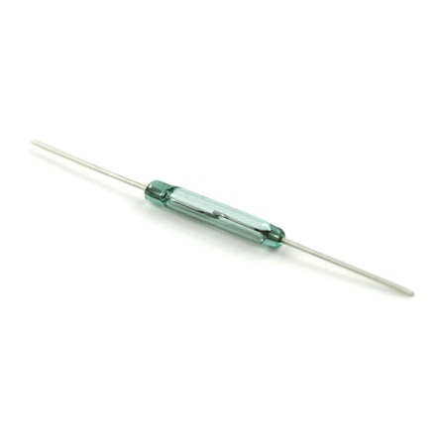

**What It Does**: A reed switch is two pieces of metal that touch when a magnet is nearby. Normally they are separated and no electricity can pass.

**What It Tells You**: If put in a circuit, the reed switch will close when a magnet is nearby, however the range varies based upon the strength of the magnet.

**Required Connections:**  
Attach one end of the switch to 5V supply on the Arduino, the other end to an **Analog Input**.

**Using the Accelerometer in Scratch:**

Use a *value of sensor* block to read in from the selected Analog Input. The switch will close when a magnet is near, causing the analog reading to approach the value 1023. If the reading is greater than 1000, it’s a good chance the magnet is near.

E:\My Dropbox\PhD\IDSA Workshop\Images\readInSwitch.png

Figure 1: Read Data from Analog Input 0

In the example below, we check to see if the magnet is present and display the words “Magnet” or “No Magnet” in the panel depending on the outcome.

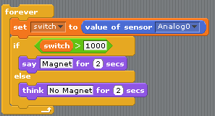

Figure 2: Checking to See If a Magnet Is Present

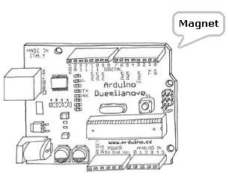

Figure 3: Arduino Saying That Magnet is Present